November 7, 2022

**BCS203193**

MUHAMMAD HARRIS – SECTION 4

Computer Organization & Assembly Language LAB

LAB 06 Practice Task

Practice Task

# Task 01



.MODEL SMALL

.DATA

space_variable DB " ","$"

.CODE

;importing data segment

mov ax, @data

mov ds, ax

;initializing loop iterator cx

mov cx, 5

mov bx, 5

;main loop for printing space

l1:

mov cx, 5 ;cx = bx

mov dl, 49d ;dl = 1

l2:

;print number and increment it

mov ah, 02

int 21h

inc dl

loop l2

;decrement outer loop

dec bx

mov cx, bx

;print space

lea dx, space_variable

mov ah, 09

int 21h

loop l1

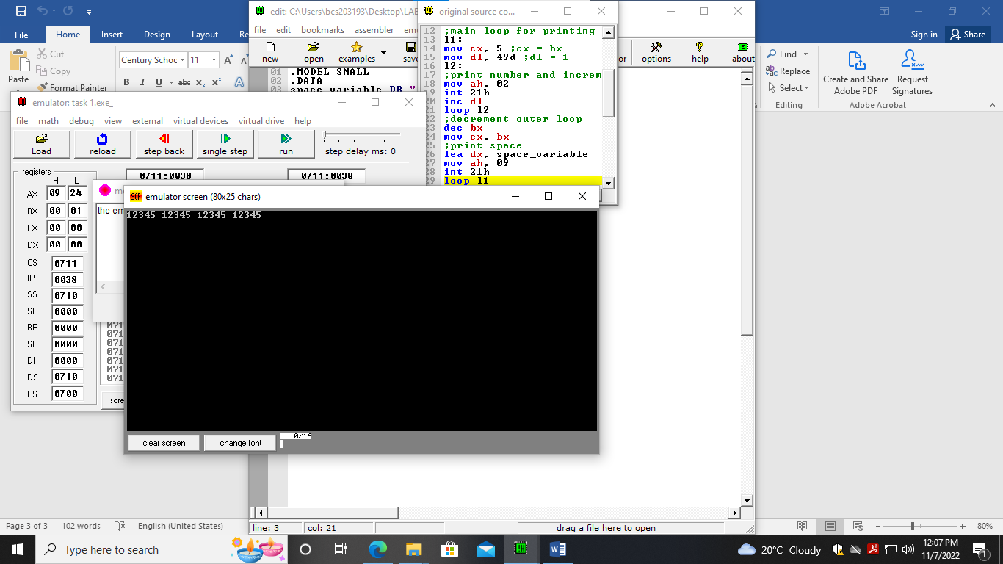

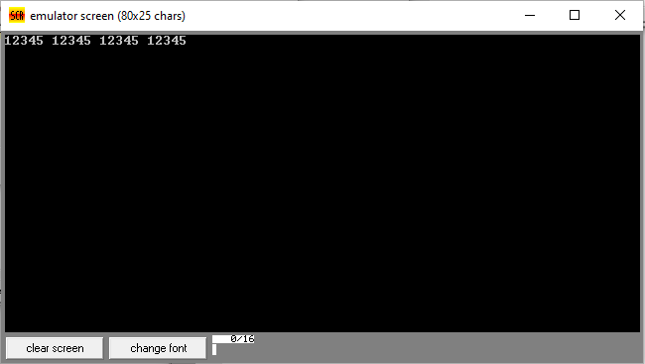

# Task 02

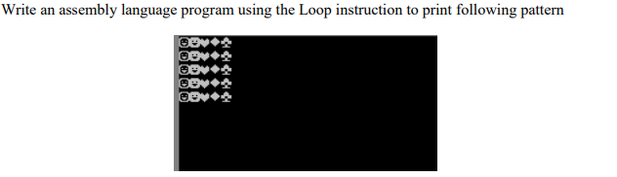

.MODEL SMALL

.DATA

endline_variable DB 0ah,0dh,"$"

.CODE

;importing data segment

mov ax, @data

mov ds, ax

;initializing loop iterator cx

mov cx, 5

mov bx, 5

;main loop for printing endline

l1:

mov cx, 5 ;cx = bx

mov dl, 1d ;dl = symbol

l2:

;print character and increment it

mov ah, 02

int 21h

inc dl

loop l2

;decrement outer loop

dec bx

mov cx, bx

;print space

lea dx, endline_variable

mov ah, 09

int 21h

loop l1

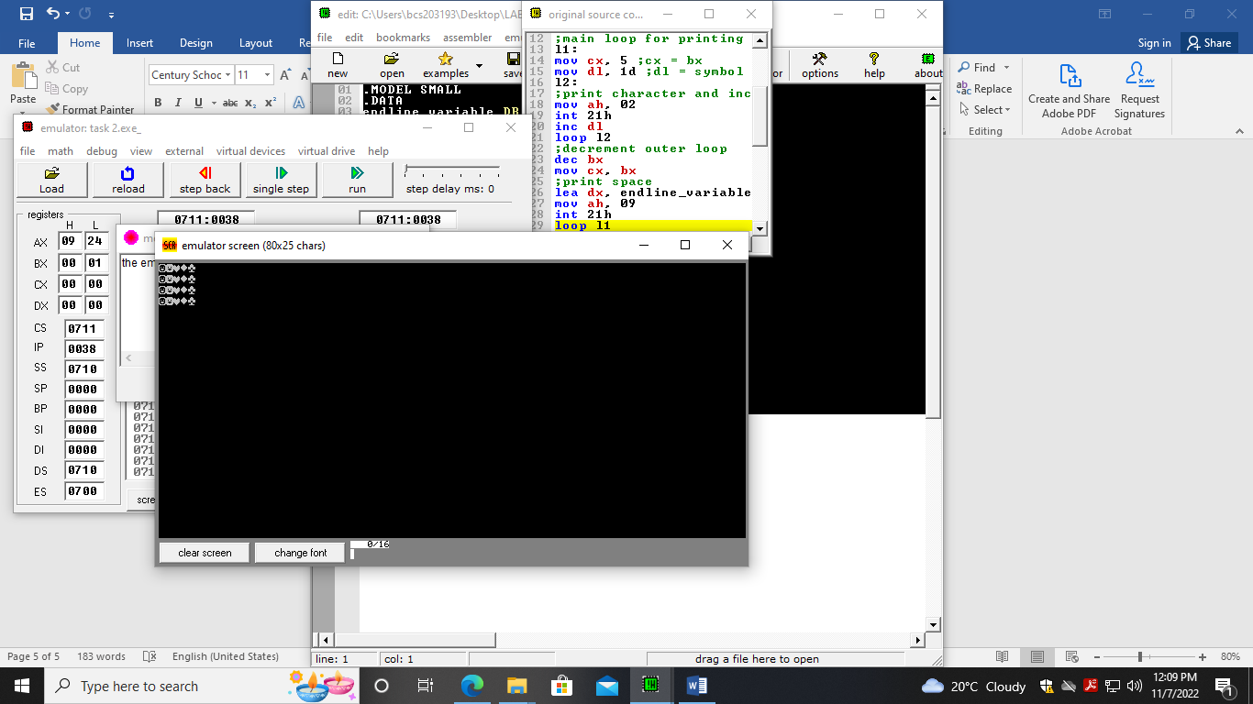

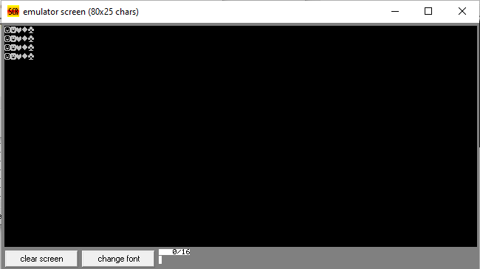

# Task 03

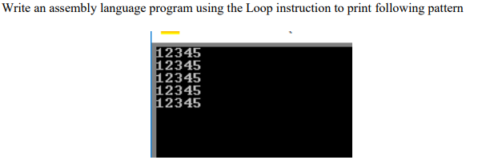

.MODEL SMALL

.DATA

endline_variable DB 0ah,0dh,"$"

.CODE

;importing data segment

mov ax, @data

mov ds, ax

;initializing loop iterator cx

mov cx, 5

mov bx, 5

;main loop for printing endline

l1:

mov cx, 5 ;cx = bx

mov dl, 65d ;dl = A a

l2:

;print alphabet and increment it

mov ah, 02

int 21h

inc dl

loop l2

;decrement outer loop

dec bx

mov cx, bx

;print space

lea dx, endline_variable

mov ah, 09

int 21h

loop l1

